Advanced Database Training
2026
Vaishnavi Kamthe

Assignment 4c

Question
Create a subscribers table using subscribers.csv file. The file contains daily subscribers data.
Considering the given table, write a query to create a view to show the cumulative sum of subscribers for each date starting from the minimum date from table till current date.
The view should contain two columns ‘date’ and ‘total_subscribers’ .
E.g if the given table has minimum date ‘2013-06-04’ and has following rows:
date | subscribers
2013-06-14 1
2013-06-16 4
2013-06-20 7
Then the view should have following rows:
date | total_subscribers
2013-06-14 1
2013-06-15 1
2013-06-16 5
2013-06-17 5
2013-06-18 5
2013-06-19 5
2013-06-20 12
Loaded the CSV and Converted to Table :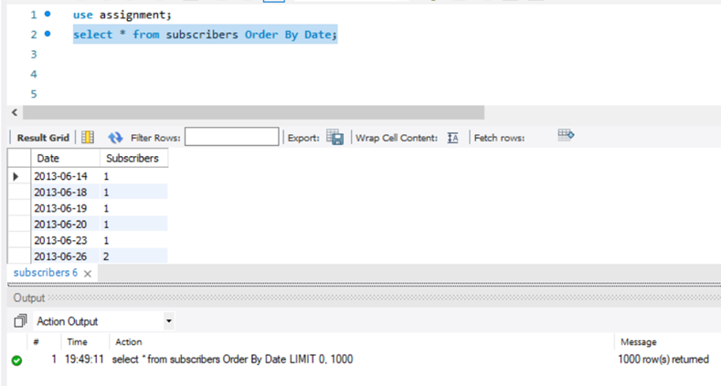
Created a New table Which had all the missings dates : 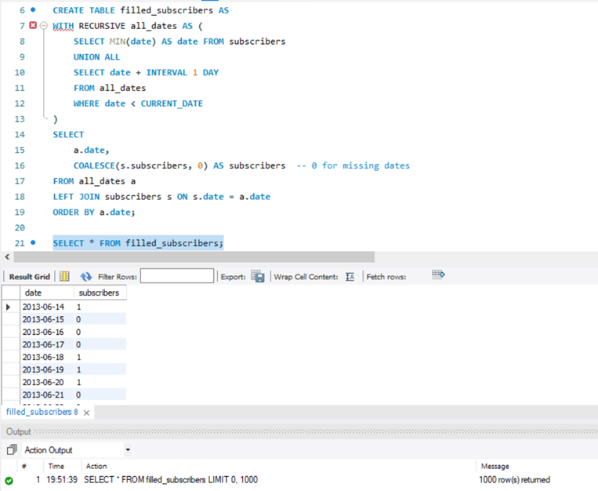
Created a View that shows the cummulative sum of subscribers :